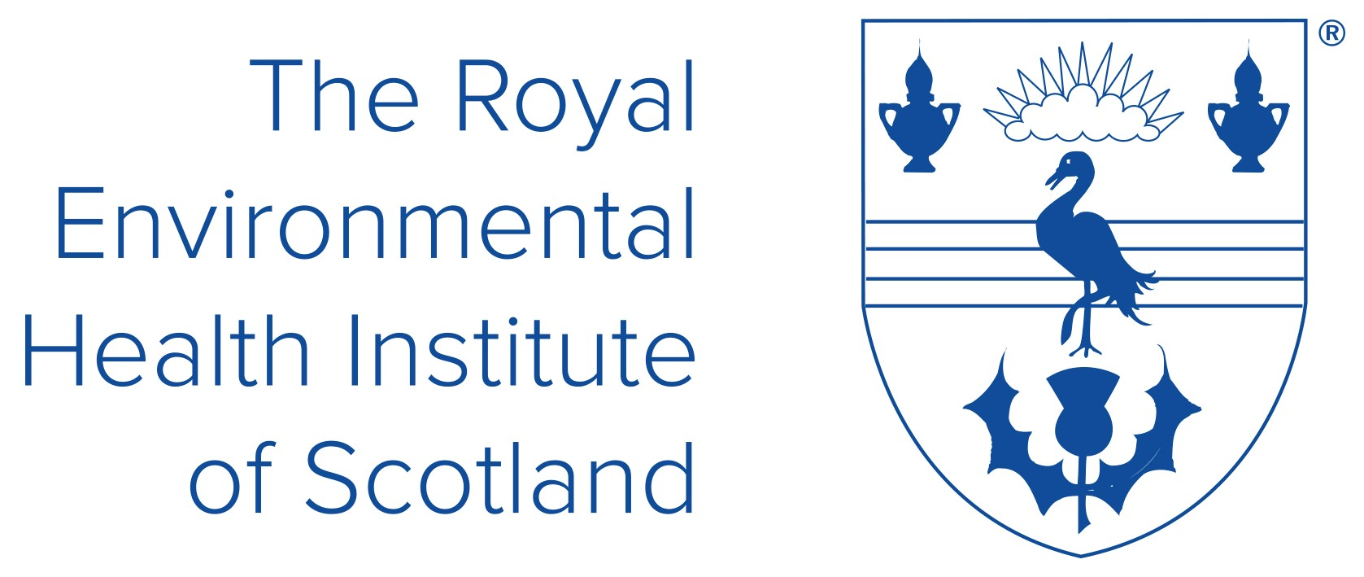
Society of Chief Officers of Environmental Health in Scotland

THE MARTIN KEELEY AWARD FOR OUTSTANDING CONTRIBUTION TO ENVIRONMENTAL HEALTH 2025

Protecting and improving public health is a fundamental objective of Environmental Health and the work of both REHIS and SOCOEHS. Recognising the contributions of our colleague, Martin Keeley, who sadly passed away in 2022, an award has been established to recognise individuals, groups or organisations for actions which have significantly promoted or improved Environmental Health (this can be for single element or wider environmental health).

Applications are invited for the MARTIN KEELEY AWARD FOR OUTSTANDING CONTRIBUTION TO ENVIRONMENTAL HEALTH 2025 by 31 July 2025 and should be submitted using the below nomination form, to contact@rehis.com

Nomination Form

PROJECT NAME
NOMINATION (individual/team/agency)
CONTACT DETAILS
NOMINEES NAME
CONTACT DETAILS | Email: | Telephone:

EXECUTIVE SUMMARY | In one short paragraph please THE REASONS FOR THE NOMINATION
DETAILS OF THE WORK OR PROJECT | Outline the work or project and what it was seeking to acheive What are you aiming to achieve
OUTCOMES | What were the outputs and outcomes?
CONTRIBUTIONS | Detail why the nomination has made a significant contribution to environmental health and the wider public health

Award Sponsors: Royal Environmental Health Institute of Scotland and the Society of Chief Officers of Environmental Health in Scotland

Please return this form to: contact@rehis.com

Presentation of the Award: The award will be presented at the REHIS 150 Anniversary Forum on 25 September in Edinburgh.

